
A Review of Modern Technology in addition to Practical Applications
Modern Technology Asset, Figure 0.5 [0]
This paper will serve the purpose of presenting findings concerning the world’s current technological climate in addition to the development of practical products.
By DHARMARLOU BOWEN
Table of Contents
I. Introduction 1
II. Home Security System 2
III. Smart Smoke Alarm 2
IV. Implementation of Solution 3
V. Evaluation 4
VI. References 5

ABSTRACT| Modern technological solutions have became more integrated into current society than any other era of human existence. The world is currently experience a boom of innovation in many fields of study, but none can be compared to the information technology market.

It is evident from EasyLogic's past products and reviews that it is becoming a recognisable name in the world of digitized products and devices that utilise real-time information. This paper was requested by the company, it is to provide an analyse of the current literature that plagues the innovative scene of modern computation. Emerging technological arenas such internet of things for example is becoming a more important and profitable markets for innovative thinking or solutions.


Trends as well as certain research and development schemes are being put in place to accommodate such a field. Once such a topic has been discussed in further detail the paper will transition to the development of a home security system as well as smart smoke alarm. The paper will then finally end on a comparative critique of both devices that will serve the purpose of reinforcing the feasibility of one over the other.
KEYWORDS| IoT (Internet of things); Real-time Information; Digitization; Logic Gates; Truth Tables; Firewalls & Encryption

Introduction
The history of technology has shown to bring great pride as well as shame to the world. It would bring pride with developments of such things such as the internet connecting humanity at the global scale; unfortunately it can be argued that the creation of something like the nuclear bomb has brought shame. The purpose of presenting technology in this juxtaposed manner is to emphasize the idea of humanity wielding a double edged sword. For each problem solved through innovate two more are created in the process.

IoT has many productive and constructive benefits to modern society, but it is not without its cause for concerns. Factors such as security and privacy always come into discussion as a greater amount of devices become integrated into the internet.
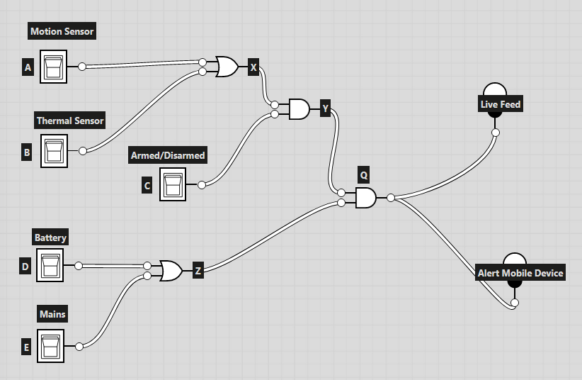
Security System Logic Diagram, Figure 1.0 [7]
Many Computer scientists have argued that it is due to the lack of IoT manufactures failing to integrate appropriate security systems in their devices. (Yang, Wu, Yin, Li∗ & Zhao, 2017) [1]

Elaborating on the concern of security systems previously mentioned, there has been a recent developing notion that human beliefs are actually capable of playing a part in the construction of the cyber security paradigm.

The development of security systems to be put in place to protect the continuity of a businesses operations is a complex task in itself. (David, Keupp & Mermoud,2020)[2]At its most abstract it is the cohesion of hardware and software, which is a straightforward factor to grasp. What makes a security system robust is not the components behind it, but the vast knowledge required to assemble the unification of hardware and software.

“rather, it is the skilled knowledge of how to organize and orchestrate these components that creates the actual defence” (Anderson, 2001; Hofmann & Ramaj, 2011; Solms & Niekerk, 2013)[3] precisely describes the relationship between knowledge and components. The key fault in this relationship is that the speed in innovation is directly proportional to how quick a previous technology becomes obsolete. As a result organisations can be left vulnerable (David, Keupp & Mermoud,2020)[4], trying to constantly acquire new specialist knowledge.

The future of IoT has the ability to eventually implement quantum cryptography as an additional layer of security. This is not to say that quantum cryptography can not be applied in many other forms of computation. There are many vulnerabilities accompanying IoT. Faults such as not possessing the ability to detect an eavesdropper. With the use of quantum cryptography such a threat can be eliminated. This is one of many fault that are discussed to greater depths in paper referenced. (Bhatt, Sharma, 2019)[5]

With all of the technological innovations that are occurring there is an increasing amount that is proving to be potentially disruptive to many career paths, effecting the feasibility of future employment for many. The raise of automation has led to the negative notions of machines replacing humans completely. It is valid to be sceptical of such technologies, but there are countless objective examples of how it has improve human life.(Nagaraj, 2020)[6]

Home Security System
The home security system requested from a recent client will consist of a battery as an alternative power source if the mains is cut, armed/disarmed upon entry of valid authentication, ringing of a mobile device when detecting an intruder, support multiple forms of detection (Thermal or Motion).

There is also an additional parameter that is to be included in the system. The feature of video streaming will provide a live feed of what the system is capturing back to its user. Below you will be able to find the logical explanation for the security system, which will make comprehending the design of the technology more coherent.

The logic diagram above displays the manner in which the each component of the security system corresponds to each other. In order the clients phone to be alerted (Rang) and receive a live feed, certain conditions have to be met.

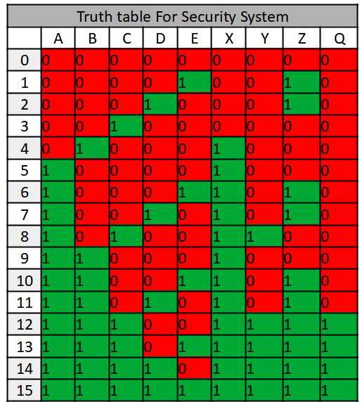
The Security has to be Armed, Powered by either a battery or mains and one of the sensors have to be triggered. If all these conditions are met then the client will receive the security's Q response. The Q response being the result if all conditions are met.

Fragmented Expression
X = A + B/ Y = X.C/ Z = D + E/ Q = (Y.Z)
Compound Expression
Q = ((A+B).C).(D+E)

Returning back to the sensors used in the security system. The thermal sensor is correlated to nocturnal monitoring as the motion sensor is not able to recognise movement from an intruder in an environment that is poorly lit. Alternatively, the motion sensor is directed towards daytime monitoring. As a result each sensor makes up for the other fault.
ESP8266 Wi-Fi Mod, Figure 4.0 [10]
Smart Alarm System Circuit Parts, Figure 3.0 [9]
Smart Alarm System Diagram, Figure 2.0 [8]

Smart Smoke Alarm
A smart smoke alarm is the product of focus for EasyLogic’s Second client (B). The alarm will demonstrate an innovative approach to a problem that has claimed many lives throughout history, house fires. Many different smoke alarm vendors have attempted to mitigate such occurrences by providing more sophisticate alerting methods.

EasyLogic will provide a product that not only demonstrates the core attributes of a smoke alarm, but a refined and evolved system that has been integrated into the internet of things. The Smart Alarm will be able to interface with a clients mobile device alerting them to an incident (via Bluetooth, Wi-Fi & 4G), in addition to an array of other features that are listened below:

- Location Identification (Room Assignment)
- Ping mobile devices (Bluetooth, SMS & Wi-Fi)
- App interface for additional features
- Hazardous Gas & Smoke Identification
- Humidity & Temperature
- Ringing Sound/Directional Voice
- Battery Charge Measuring
- RGB LED for identification

The smart alarm will have downloadable application to function with it providing the user will the ability to monitor when they may need to change the battery. Additionally, the app can relay stats about the Humidity, Temperature and scheduled air quality checks from each smart alarm.

Each alarm can be assigned an identifier via the app so the user can check and monitor a given room (Kitchen, Bedroom or living room etc). Through smart interfacing the alarms are able to communicate with each other enabling the synchronising of data. This will result in the alarms calculating how far hazardous gas or smoke has travelled from its source of origin.
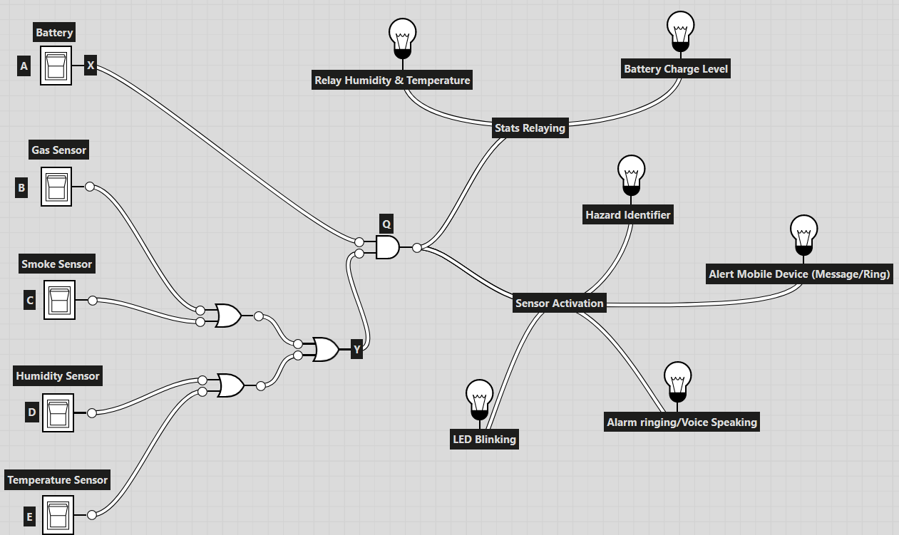
Depending on factors such as density and frequency of the smoke or gas, the alarms will pinpoint the estimated source. Alarms are equipped with an RGB LED that allow the user to set different colours for each alarm. The LED will work in unison with speaker that emits a pulsating sound, while a voice is played over it alerting the users of either smoke or hazardous gas being detected.

Within figure 2.0 there are two subsections that occur after the Q response has been activated. Each serves the purpose of fragmenting different processes either relaying statistics from each system or the activation of the sensors.

Boolean Expression Below:
X = X
Y = (B + C + D + E)
Q = (Y.Z)

Implementation of Solution
Now that the design stage has been completed, the next rational step is the implementation of the solution. The software used to implement the smart alarm is known as Tinker-cad, this is due to the visual features it provides when constructing simulations.

In order for the smart alarm to function properly and as intended. Certain components will have to be able to communicate with each other in addition to giving responsive outputs to a clients mobile device based on what input data is received. Below is an abstraction of the entire device will all the different components that are going to be used:

- Battery (9v)
- Smoke Gas Sensor (MQ-3)
- Humidity & Temperature Sensor (-55 to 125°C)
- LED (RGB)
- Circuit board (Arduino UNO)
- Speaker (For Pre-recorded Voice)
- NICs (ESP8266 = Wi-Fi Module)
- Breadboard (Later adapted to a PCB)
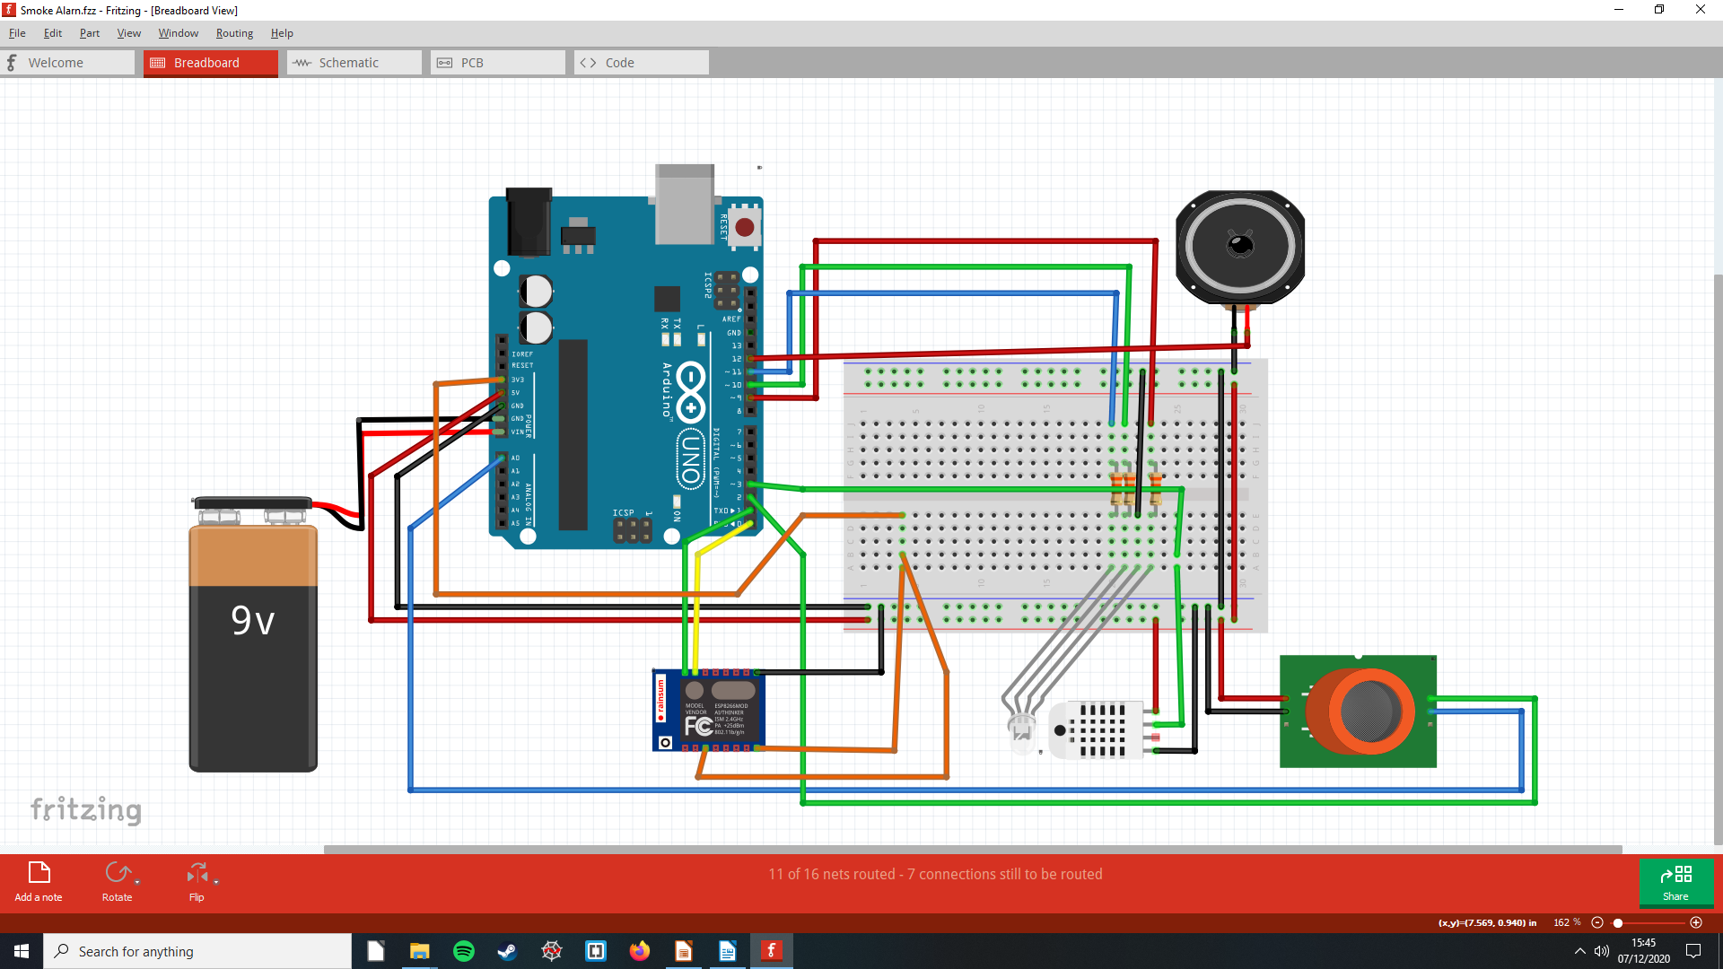
The image above (Figure 3.0) presents the entire hardware perspective of the physical elements that the product is composed of. There is additional programming that goes into the development of this product concerning the application UI, but this section will focus on hardware particularly.

The base component for then system is an Arduino UNO, it serves as the motherboard for connecting all the components together. A 9v battery serves as a power source for the system. All the other components are modules that provide different functionalities to the alarm. The sensor modules used for in the alarm are a 2 in 1 Humidity & Temperature sensor, the other is Gas & Smoke sensor.
Besides these components are a speaker, Wi-Fi module (ESP8266, Figure 4.0) and a RGB LED. The system would be placed inside a plastic case for ceiling and wall instalment.

In the instance of product operation once installed and synchronised with the clients phone or other alarms then it will begin to monitor its surrounding through its sensors.
This data in turn will be relayed back its accompanying application on the users mobile. Such a feature allows it to function as an alarm as well as a monitoring system of temperature and humidity.
The Wireless Module will enable the smart alarm to communicate with other devices. Components such as the speaker and LED are analogue alerting methods of getting the consumers attention in the event of an incident. The speaker was used over a buzzer as it provides the option to play a with with the ringing sound. The LED on the other hand serves as an alarm identifier as well as attention drawer.

In the instance where think smoke engulfed a room, the different colours designated to each room may help with navigated to an exit.

Evaluation
The final section of this article will place an emphasis on presenting a conclusive recommendation that between the two products provided by EasyLogic. It will examine how facets of the information industry such as technological competitiveness can drive innovation of a product. This is not to expel the role of a consumer in the manufacturing process, but elaborate on the importance of a free market.

The first factor taken into account is how each product helps its users. The smart alarm helps its user by monitoring the environmental status of a room concerning factors such as air quality, temperature and humidity.

The product goes beyond its core purpose by offering a compound device that may require other separate components for the same package. The security system does provide what is intend, but is doesn’t go beyond what other products of similar purposes provide.

In all forms of technology, room for improve is common trope to push innovation. Each product serves its given purpose, but to what extent. As aforementioned the security system offers basic motion and thermal detection, but would provide more protection and security if it possessed the ability to check that all doors and windows are locked. An adaption like this would reinforce the product as a stable in the physical security realm.

The smart smoke alarm serves its core purpose and goes beyond what is intend, but implementing additional functionality such as creating a whole package where special foam or sprinkler systems would be able to remedy such incidents. The key drawback is that such a package may not be cost effective.

Manufacturing products in the information industry can vary from product to product, but in this instance the security system will be hindered more than the smart alarm. This is due to their basic functions. The smart alarm monitors for hazardous incidents occurring.

Security considerations

The different considerations that have to be taken into account for each product will vary to a degree as one is already within the security industry. As both take an IoT approach to provide consumer solutions and emphasis on security for the smart alarm system would be more relevant. This is because it utilises an application that may provide an attacker the ability to pivot into a home network of a consumer.
For ensuring that the communication between the alarms and the devices they are synchronised to are secure cyber security professionals would pen test the alarms. Through such consultation, they would be able to reinforce any vulnerabilities found by implementing different encryption techniques or firewall configuration for monitoring wireless transmission.

This is relevant to the manufacturing process, but limited on the consumer side as a client negligence could lead to a breach in security. To combat this, a type of authentication would be required to make change to settings or preferences of the alarms via the app. So even in the event where a user happen to leave their phone unlock an additional layer of security would be in place.

With the home security system, there is the vulnerability of the live feed that is sent to the user from a camera being tapped. This is a core concern as such an occurrence does not present or manifest itself in a physical action, its passive and can possibly go unnoticed until a security check is performed. Such an event demonstrated why security processes are necessary.

References
[0] Technology Image Asset, Figure 0.5, https://www.swipsystems.com/2019/04/18/use-technology-to-build-a-positive-company-culture-your-bottom-line-depends-on-it/

[1] Yuchen Yang, Longfei Wu, Guisheng Yin, Lijie Li, and Hongbin Zhao (2017) A Survey on Security and Privacy Issues in
Internet-of-Things, Published by IEEE, https://www.researchgate.net/publication/316173391_A_Survey_on_Security_and_Privacy_Issues_in_Internet-of-Things

[2] Dimitri Percia David, Marcus Matthias Keupp and Alain Mermoud (2020) Knowledge absorption for cyber-security: The role of human beliefs (Vol 106), Published by ELSEVIER, https://www.researchgate.net/publication/338529576_Knowledge_absorption_for_cyber-security

[3] Anderson, Ross (2001). Why information security is hard – an economic perspective. In Seventeenth annual computer security applications conference, Annual computer security applications conference (pp. 358–365). New Orleans, USA: IEEE, http://dx.doi.org/10.1109/ACSAC.2001.991552

[4]Dimitri Percia David, Marcus Matthias Keupp and Alain Mermoud (2020) Knowledge absorption for cyber-security: The role of human beliefs (Vol 106), Published by ELSEVIER, https://www.researchgate.net/publication/338529576_Knowledge_absorption_for_cyber-security

[5] Alekha Parimal Bhatt, Anand Sharma (2019), Quantum Cryptography for Internet of Things
Security, Published by ELSEVIER,
https://www.sciencedirect.com/science/article/pii/S1674862X19300345#:~:text=%20Quantum%20Cryptography%20for%20Internet%20of%20Things%20Security,in%20terms%20of%20the%20security%20of...%20More%20

[6] S.V.Nagaraj (2020), Disruptive technologies that are likely to shape future jobs, Published by ELSEVIER,
https://www.researchgate.net/publication/342221829_Disruptive_technologies_that_are_likely_to_shape_future_jobs

[7] The diagram was made by me using the application logic.ly, found at the link: https://logic.ly/demo

[8] The diagram was made by me using the application logic.ly, found at the link: https://logic.ly/demo

[9] The Circuit Diagram was made with Fritzing by me

[10] The Circuit Diagram was made with Fritzing, displaying Wi-Fi Module

Acknowledgments

- Birmingham University Computing & Digital Media Faculty (Providing information and links for academic writing/ work structure)


ABOUT THE AUTHOR

Dharmarlou Bowen is a first year undergrad currently (2020-2023) studying a Bachelors in Computer Science at Birmingham City University, West Midlands, England, United Kingdom. He has often expressed his intrigue in artificial intelligence and plans to pursue it to greater depths once he has finished his bachelors.

